Reducing Victim-Location Delays During Avalanche Rescue Operations at Colorado Ski Resorts Using Unmanned Aerial Vehicle Localization Systems

Saad Al-Dossary (202358970)
English Language Department, King Fahd University of Petroleum and Minerals
ENGL 214: Academic and Professional Communication
Mr. Luke Delahunty
July 27, 2026
1,878 Words

Descriptive Abstract
The purpose of this report is to analyze the factors contributing to victim-location delays during avalanche rescue operations at Colorado ski resorts and to examine the effectiveness of unmanned aerial vehicle (UAV) localization systems in reducing victim-location delays. The report discusses the lack of precise victim-location information, the limitations of RECCO handheld radar detection, and the inability of thermal imaging systems to detect victims buried beneath avalanche debris. It also evaluates the battery endurance of UAV localization systems as a technological limitation.

Contents
1 Causes of Victim-Location Delays in Avalanche Rescue Operations 5
1.1 Current Rescue Operations Begin Without Precise Victim-Location Information 5
1.2 RECCO Detection Requires Rescuers to Physically Sweep Avalanche Debris 6
1.3 Thermal Imaging Cannot Detect Victims Buried Beneath Avalanche Debris 7
2 UAV Localization Systems for Reducing Victim-Location Delays 8
2.1 UAV-Based Cellular Signal Localization for Precise Victim Detection 8
2.2 UAV-Mounted Radar Reduces the Need for Physical Debris Sweeping 8
2.3 UAV-Based Wireless Signal Detection for Buried Victim Localization 10
3 Evaluation of UAV Battery Endurance 11
4 Conclusion 11
5 Recommendations 12
References 13

In Colorado, skiing is one of the most popular recreational activities, attracting millions of visitors each winter. During the 2024–2025 season, Colorado ski resorts recorded approximately 13.8 million skier visits, making it the state's third-busiest ski season on record (Blevins, 2025). According to the Colorado Avalanche Information Center (2024), the state recorded 120 avalanche incidents involving 149 people during the 2023–2024 season. Although skiing contributes significantly to Colorado's economy, skiers who pass through resort access gates remain exposed to avalanches that may require emergency rescue operations. During these operations, rescuers cannot begin evacuation or medical treatment until the victim's location has been accurately identified. Therefore, delays in locating victims reduce survival rates and decrease the effectiveness of rescue operations. Major factors contributing to victim-location delays during avalanche rescue operations at Colorado ski resorts include the lack of precise victim-location information at the start of rescue operations, the limitations of RECCO handheld radar detection, and the inability of thermal imaging systems to detect victims buried beneath avalanche debris.
The purpose of this report is to analyze the factors contributing to victim-location delays during avalanche rescue operations at Colorado ski resorts and to evaluate the effectiveness of unmanned aerial vehicle (UAV) localization systems in reducing these delays.
This report focuses on victim-location delays during avalanche rescue operations at Colorado ski resorts and examines UAV localization systems while excluding avalanche prevention strategies and post-rescue medical treatment. The report is intended for educated lay readers interested in mountain rescue technologies.

Causes of Victim-Location Delays in Avalanche Rescue Operations

Current Rescue Operations Begin Without Precise Victim-Location Information
One significant reason for victim-location delays during avalanche rescue operations at Colorado ski resorts is that rescue teams begin operations without precise information about the injured skier's location. When a skiing incident is reported, rescue teams are dispatched using the location information available from emergency callers or witnesses. However, this information identifies the caller's position rather than the victim's location. Location coordinates obtained from cell phone pings on nearby cellular towers often provide only a general indication of a caller's location and are not sufficiently precise for rescuers to locate victims efficiently (Colorado Search and Rescue Association, 2024). As a result, rescuers must search the reported area before evacuation or medical treatment can begin. Similarly, Lunde and Tellefsen (2019) found that, in 29 Norwegian avalanche accidents, rescuers still had to locate 55 victims after arriving at the incident scene. This shows that reaching the reported scene does not remove the need for further searching. Hence, the absence of precise victim-location information at the beginning of rescue operations delays first aid and evacuation during avalanche rescue operations at Colorado ski resorts.

RECCO Detection Requires Rescuers to Physically Sweep Avalanche Debris
A further cause of victim-location delays during avalanche rescue operations at Colorado ski resorts is that RECCO detection requires rescuers to physically sweep avalanche debris before locating buried victims. RECCO is a harmonic radar system that detects passive reflectors embedded in victims' clothing or equipment using reflected radar signals. As shown in Figure 1, the handheld detector transmits a radar signal toward the victim's reflector and identifies the location only after receiving the reflected signal. The RECCO system has a limited detection range because dense or wet snow can weaken the radar signal (Van Tilburg et al., 2024). Therefore, rescuers must systematically sweep the avalanche debris until the detector comes within range of a buried victim's reflector. Because the detector identifies reflectors at close range, rescuers must cover the debris field on foot rather than scanning it from a single position. Hence, the search time required for RECCO detection grows with the size of the avalanche debris field, delaying victim localization at Colorado ski resorts.
Figure 1
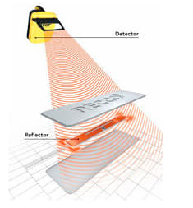
Operating Principle of the RECCO Rescue System

Note. From Janovec et al. (2022).

Thermal Imaging Cannot Detect Victims Buried Beneath Avalanche Debris
Another major reason for victim-location delays during avalanche rescue operations at Colorado ski resorts is that thermal imaging systems cannot detect injured victims buried beneath avalanche debris. Thermal cameras detect heat emitted from the human body and are effective when victims are visible on the snow surface or only partially covered by objects such as rocks. However, thermal cameras become ineffective when victims are completely buried beneath avalanche debris because the snow prevents sufficient body heat from reaching the camera. Thermal cameras are unable to identify body heat through snow deeper than 20 cm (Silvagni et al., 2017, as cited in Janovec et al., 2022). Because complete burial places a victim beneath more snow than this threshold, thermal imaging is effective only when individuals are visible or only partially buried and offers little assistance in locating those who are completely buried. Therefore, rescuers must search large debris areas using slower ground-based methods.

UAV Localization Systems for Reducing Victim-Location Delays

UAV-Based Cellular Signal Localization for Precise Victim Detection
UAV-based cellular signal localization reduces delays caused by imprecise victim-location information at Colorado ski resorts because it locates an injured skier's mobile phone from the air before any ground search begins. This technology uses a drone equipped with a cellular communication system to locate the injured skier's mobile phone. After an emergency call is received, the drone flies over the suspected avalanche area, detects the wireless signal from the skier's phone, and combines it with its GPS location to determine the victim's position. It then transmits these coordinates to the rescue team so evacuation can begin. As a result, rescuers can travel to the victim's location rather than spending valuable time searching vast avalanche areas. Albanese et al. (2022) field-tested the search-and-rescue drone-based solution for victim localization (SARDO), which localized victims' mobile phones in approximately 3 minutes while requiring only 5% additional UAV battery consumption at an operating altitude of 100 m. Because SARDO achieved this from that altitude, the drone can rapidly survey the area, allowing rescuers to travel straight to the skier instead of searching the reported area first.

UAV-Mounted Radar Reduces the Need for Physical Debris Sweeping
UAV-mounted radar systems reduce the need for physical debris sweeping during avalanche rescue operations at Colorado ski resorts because they estimate buried victims' locations before rescuers begin searching the avalanche debris field. These systems detect buried victims remotely by transmitting electromagnetic waves through the snow surface and processing the reflected signals. A UAV-mounted radar system consists of a drone equipped with a downward-facing radar sensor that scans the avalanche area and estimates the location of buried victims before rescuers begin the ground search. Unlike handheld RECCO detectors, the UAV-mounted radar scans the avalanche remotely before rescuers enter the debris field, eliminating the need for extensive physical sweeping. As illustrated in Figure 2, the colored clusters represent the radar detections, while the colored boxes indicate the actual locations of the buried targets beneath the snow. The figure shows that most radar detections are near the actual positions of the buried targets, although some targets produce weaker or no detections. By identifying potential victim locations before rescuers enter the avalanche area, the system allows rescue teams to focus their search on a much smaller area rather than sweeping the entire debris field on foot. Grathwohl et al. (2021) detected buried torsos up to 40 cm deep in dense, wet snow and found that greater depths are likely detectable in the drier snow of most avalanches. This shows that UAV-mounted radar can locate buried victims from the air, allowing rescuers to target suspected victim locations instead of manually sweeping the entire debris field.
Figure 2
Experimental Detection of Buried Targets Using a UAV-Mounted Radar System
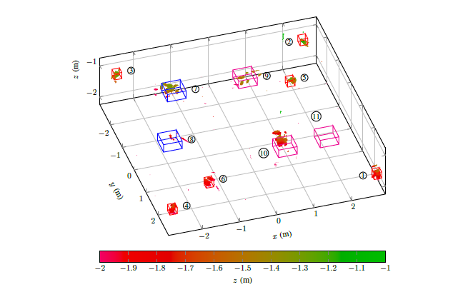
Note. From Grathwohl et al. (2021).

UAV-Based Wireless Signal Detection for Buried Victim Localization
UAV-based wireless signal detection reduces victim-location delays at Colorado ski resorts because it locates completely buried skiers from the air by detecting signals transmitted by their avalanche transceivers, which are not blocked by snow in the way body heat is blocked. Unlike thermal imaging, which cannot detect victims buried beneath avalanche debris, UAV-based wireless signal detection remains effective because avalanche-transceiver signals can still be detected through snow. The UAV detects the buried skier's transceiver signal, determines the victim's location using GPS, and transmits the coordinates directly to rescuers. Therefore, rescue teams can travel directly to the victim's location instead of spending significant time searching through avalanche debris. Stasik and Szandała (2025) reported that their autonomous UAV located a buried avalanche transceiver within several minutes, whereas manual rescuer sweeps typically require 20–30 minutes or more. Since the drone detects the avalanche transceiver within a few minutes rather than the 20–30 minutes required for a manual sweep, rescuers can reach buried skiers sooner during the critical survival period. Moreover, because snow does not block avalanche transceiver signals in the same way it blocks body heat, the system can locate completely buried victims even when thermal imaging cannot detect their body heat.

Evaluation of UAV Battery Endurance
Despite the advantages of UAV localization systems in reducing victim-location delays during avalanche rescue operations at Colorado ski resorts, their effectiveness is limited by the relatively short battery endurance of UAVs, particularly in subzero temperatures. Li et al. (2021) found that temperatures below 0 °C significantly reduced the battery's discharge capacity, shortening flight endurance in the cold conditions where avalanche rescues take place. However, automated battery management systems can reduce this limitation. Ure et al. (2015) developed an automated battery-swapping system that rapidly replaces depleted batteries with fully charged ones while simultaneously recharging other batteries. During flight testing, the system successfully supported a five-hour autonomous mission with approximately 91% vehicle utilization, demonstrating that battery replacement can keep a UAV searching an avalanche site with minimal interruption instead of being grounded when its battery is depleted. Although limited battery endurance remains an operational challenge, battery-management technologies can mitigate its impact by allowing UAVs to quickly continue searching for avalanche victims after a battery replacement, reducing delays in locating avalanche victims at Colorado ski resorts.

Conclusion
In conclusion, victim-location delays at Colorado ski resorts stem primarily from imprecise victim-location information, the need to physically sweep debris using RECCO detection, and thermal imaging's inability to detect buried victims. This report evaluated three UAV localization technologies to address these challenges: cellular signal localization, UAV-mounted radar, and wireless signal detection. Although limited battery endurance presents an operational challenge, effective battery management technologies can reduce its impact. Overall, implementing these UAV localization systems has the potential to improve avalanche rescue operations at Colorado ski resorts by reducing victim-location delays.

Recommendations
Implementing UAV localization systems at Colorado ski resorts requires coordination among aviation controllers, sheriff's offices, and rescue teams. Thus, the following recommendations are proposed:
- The Federal Aviation Administration should establish a pre-approved protocol for launching UAVs beyond visual line of sight during avalanche incidents, so that legal clearance does not delay a search when minutes determine survival.
- Colorado sheriff's offices should assign dedicated UAV localization teams to avalanche rescue operations so that aerial searches can begin immediately without diverting personnel from other emergency duties.
- Colorado search and rescue teams should adopt a shared mapping system that displays a UAV's victim-location coordinates directly on rescuers' devices, so that the drone's data reaches ground teams instantly instead of being relayed verbally.

References
Albanese, A., Sciancalepore, V., & Costa-Pérez, X. (2022). SARDO: An automated search-and-rescue drone-based solution for victims localization. IEEE Transactions on Mobile Computing, 21(9), 3312–3325. https://doi.org/10.1109/TMC.2021.3051273
Blevins, J. (2025, June 5). Colorado ski areas report 13.8 million visits in 2024–25, marking the third busiest season ever. The Colorado Sun. https://coloradosun.com/2025/06/05/colorado-skier-visits-third-busiest-season/
Colorado Avalanche Information Center. (2024, October 4). 2023–24 season summary. https://avalanche.state.co.us/blog/2023-24-season-summary
Colorado Search and Rescue Association. (2024, May 25). How to make the perfect 911 call from the backcountry. https://coloradosar.org/how-to-make-the-perfect-911-call-from-the-backcountry/
Grathwohl, A., Hinz, P., Burr, R., Steiner, M., & Waldschmidt, C. (2021). Experimental study on the detection of avalanche victims using an airborne ground penetrating synthetic aperture radar. 2021 IEEE Radar Conference (RadarConf21), 1–6. https://doi.org/10.1109/RadarConf2147009.2021.9455286
Janovec, M., Kandera, B., & Šajbanová, K. (2022). Using unmanned aerial vehicles during the search of people buried in an avalanche. Transportation Research Procedia, 65, 350–360. https://doi.org/10.1016/j.trpro.2022.11.039
Li, N., Liu, X., Yu, B., Li, L., Xu, J., & Tan, Q. (2021). Study on the environmental adaptability of lithium-ion battery powered UAV under extreme temperature conditions. Energy, 219, 119481. https://doi.org/10.1016/j.energy.2020.119481
Lunde, A., & Tellefsen, C. (2019). Patient and rescuer safety: Recommendations for dispatch and prioritization of rescue resources based on a retrospective study of Norwegian avalanche incidents 1996–2017. Scandinavian Journal of Trauma, Resuscitation and Emergency Medicine, 27, 5. https://doi.org/10.1186/s13049-019-0585-7
Stasik, J., & Szandała, T. (2025). An autonomous drone for avalanche search and rescue: Integrating ArduPilot and Tracking-Beacon detection. IEEE Access, 13, 130758–130769. https://doi.org/10.1109/ACCESS.2025.3585245
Ure, N. K., Chowdhary, G., Toksoz, T., How, J. P., Vavrina, M. A., & Vian, J. (2015). An automated battery management system to enable persistent missions with multiple aerial vehicles. IEEE/ASME Transactions on Mechatronics, 20(1), 275–286. https://doi.org/10.1109/TMECH.2013.2294805
Van Tilburg, C., Paal, P., Strapazzon, G., Grissom, C. K., Haegeli, P., Hölzl, N., McIntosh, S., Radwin, M., Smith, W. R., Thomas, S., Tremper, B., Weber, D., Wheeler, A. R., Zafren, K., & Brugger, H. (2024). Wilderness Medical Society clinical practice guidelines for prevention and management of avalanche and nonavalanche snow burial accidents: 2024 update. Wilderness & Environmental Medicine, 35(1 Suppl.), 20S–44S. https://doi.org/10.1016/j.wem.2023.05.014

Source 1
Paraphrase, Quotation, or Figure/Table Within Report
Albanese et al. (2022) field-tested the search-and-rescue drone-based solution for victim localization (SARDO), which localized victims' mobile phones in approximately 3 minutes while requiring only 5% additional UAV battery consumption at an operating altitude of 100m.
Location in Report
Under section 2.1 – page 8
Original Source Reference
Albanese, A., Sciancalepore, V., & Costa-Pérez, X. (2022). SARDO: An automated search-and-rescue drone-based solution for victims localization. IEEE Transactions on Mobile Computing, 21(9), 3312–3325. https://doi.org/10.1109/TMC.2021.3051273
Page or Paragraph Number in Original Source
Page 3323
Subcategory 7.4 Proof of Concept Experimental Results
Image of Item, With Highlighting
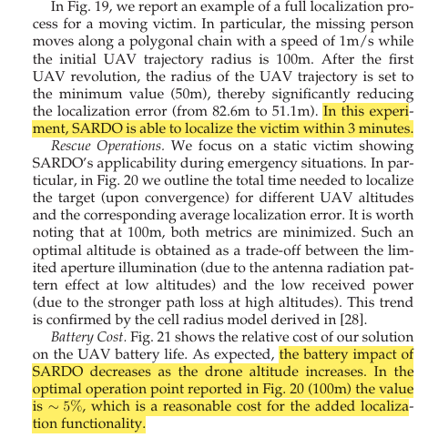
Source 2
Paraphrase, Quotation, or Figure/Table Within Report
Figure 1:
As shown in Figure 1, the handheld detector transmits a radar signal toward the victim's reflector and identifies the location only after receiving the reflected signal.
Paraphrase 2:
Thermal cameras are unable to identify body heat through snow deeper than 20 cm (Silvagni et al., 2017, as cited in Janovec et al., 2022).
Location in Report
Section 1.2 – Figure 1 – Page 6
Section 1.3 – Paraphrase 2 – Page 7
Original Source Reference
Janovec, M., Kandera, B., & Šajbanová, K. (2022). Using unmanned aerial vehicles during the search of people buried in an avalanche. Transportation Research Procedia, 65, 350–360. https://doi.org/10.1016/j.trpro.2022.11.039
Page or Paragraph Number in Original Source
Figure 1: Page 353
Paraphrase 2: (citing Silvagni et al., 2017) – Page 354

Image of Item, With Highlighting
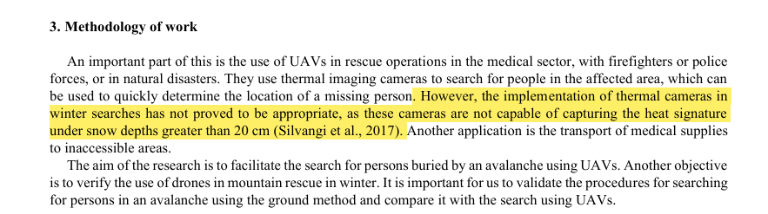
Source 3
Paraphrase, Quotation, or Figure/Table Within Report
Lunde and Tellefsen (2019) found that, in 29 Norwegian avalanche accidents, rescuers still had to locate 55 victims after arriving at the incident scene.
Location in Report
Under section 1.1 – page 5
Original Source Reference
Lunde, A., & Tellefsen, C. (2019). Patient and rescuer safety: Recommendations for dispatch and prioritization of rescue resources based on a retrospective study of Norwegian avalanche incidents 1996–2017. Scandinavian Journal of Trauma, Resuscitation and Emergency Medicine, 27, 5. https://doi.org/10.1186/s13049-019-0585-7
Page or Paragraph Number in Original Source
Page 5
Image of Item, With Highlighting
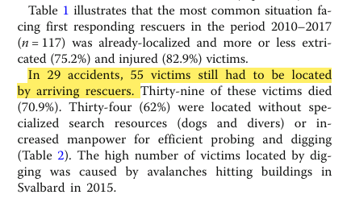

Source 4
Paraphrase, Quotation, or Figure/Table Within Report
During the 2024–2025 season, Colorado ski resorts recorded approximately 13.8 million skier visits, making it the state's third-busiest ski season on record (Blevins, 2025).
Location in Report
Introduction – Page 4
Original Source Reference
Blevins, J. (2025, June 5). Colorado ski areas report 13.8 million visits in 2024–25, marking the third busiest season ever. The Colorado Sun. https://coloradosun.com/2025/06/05/colorado-skier-visits-third-busiest-season/
Page or Paragraph Number in Original Source
Paragraph 1
Image of Item, With Highlighting

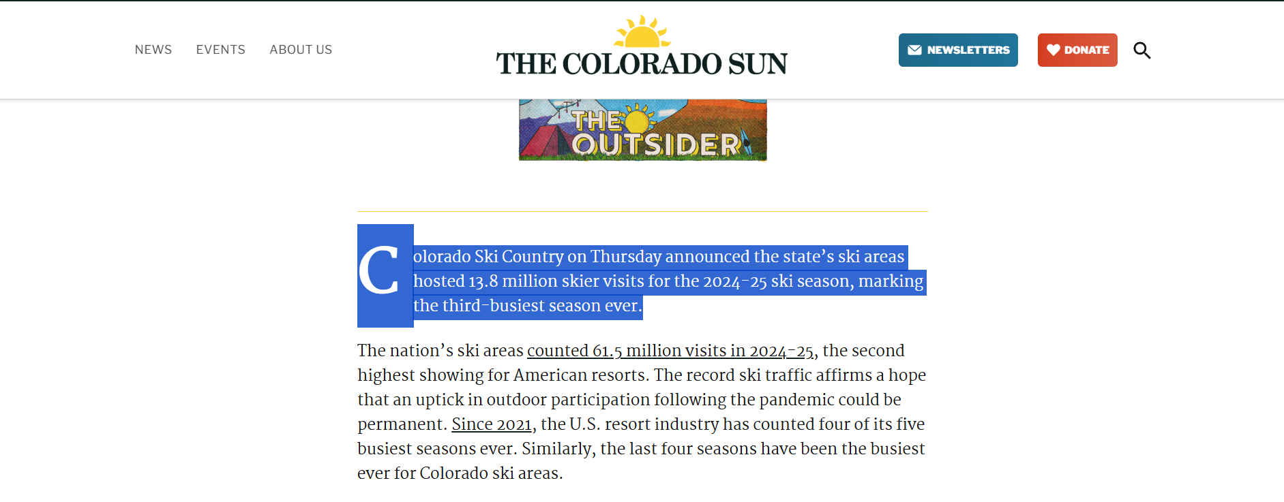
Source 5
Paraphrase, Quotation, or Figure/Table Within Report
The RECCO system has a limited detection range because dense or wet snow can weaken the radar signal (Van Tilburg et al., 2024).
Location in Report
Under section 1.2 – page 6
Original Source Reference
Van Tilburg, C., Paal, P., Strapazzon, G., Grissom, C. K., Haegeli, P., Hölzl, N., McIntosh, S., Radwin, M., Smith, W. R., Thomas, S., Tremper, B., Weber, D., Wheeler, A. R., Zafren, K., & Brugger, H. (2024). Wilderness Medical Society clinical practice guidelines for prevention and management of avalanche and nonavalanche snow burial accidents: 2024 update. Wilderness & Environmental Medicine, 35(1 Suppl.), 20S–44S. https://doi.org/10.1016/j.wem.2023.05.014
Page or Paragraph Number in Original Source
Page 21S / Page 28S
Image of Item, With Highlighting
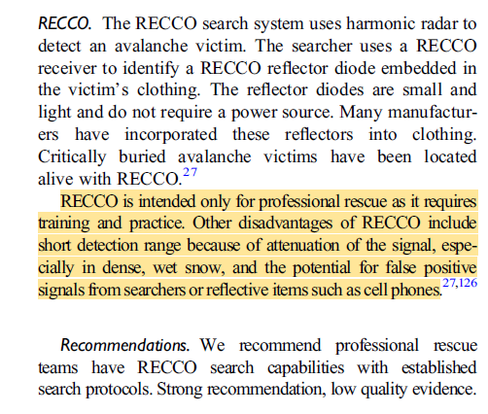
Source 6
Paraphrase, Quotation, or Figure/Table Within Report
Location coordinates obtained from cell phone pings on nearby cellular towers often provide only a general indication of a caller's location and are not sufficiently precise for rescuers to locate victims efficiently (Colorado Search and Rescue Association, 2024).
Location in Report
Under section 1.1 – page 5
Original Source Reference
Colorado Search and Rescue Association. (2024, May 25). How to make the perfect 911 call from the backcountry. https://coloradosar.org/how-to-make-the-perfect-911-call-from-the-backcountry/
Page or Paragraph Number in Original Source
Paragraph 5
Image of Item, With Highlighting
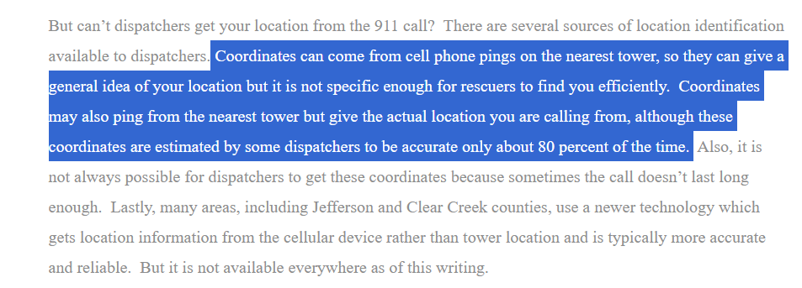

Source 7
Paraphrase, Quotation, or Figure/Table Within Report
Figure 2:
As illustrated in Figure 2, the colored clusters represent the radar detections, while the colored boxes indicate the actual locations of the buried targets beneath the snow.
Paraphrase:
Grathwohl et al. (2021) detected buried torsos up to 40 cm deep in dense, wet snow and found that greater depths are likely detectable in the drier snow of most avalanches.
Location in Report
Both under section 2.2 – Page 9
Original Source Reference
Grathwohl, A., Hinz, P., Burr, R., Steiner, M., & Waldschmidt, C. (2021). Experimental study on the detection of avalanche victims using an airborne ground penetrating synthetic aperture radar. 2021 IEEE Radar Conference (RadarConf21), 1–6. https://doi.org/10.1109/RadarConf2147009.2021.9455286
Page or Paragraph Number in Original Source
Figure-page 5
Paraphrase-page 6
Image of Item, With Highlighting
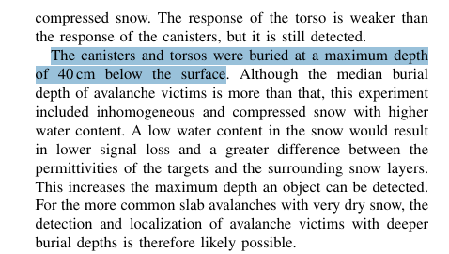
Source 8
Paraphrase, Quotation, or Figure/Table Within Report
Li et al. (2021) found that temperatures below 0 °C significantly reduced the battery's discharge capacity, shortening flight endurance in the cold conditions where avalanche rescues take place.
Location in Report
Under Evaluation Section- page 11
Original Source Reference
Li, N., Liu, X., Yu, B., Li, L., Xu, J., & Tan, Q. (2021). Study on the environmental adaptability of lithium-ion battery powered UAV under extreme temperature conditions. Energy, 219, 119481. https://doi.org/10.1016/j.energy.2020.119481
Page or Paragraph Number in Original Source
Page 10
Image of Item, With Highlighting
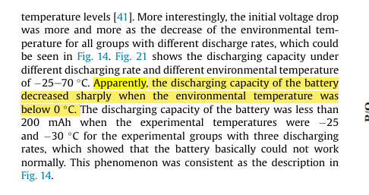

Source 9
Paraphrase, Quotation, or Figure/Table Within Report
Stasik and Szandała (2025) reported that their autonomous UAV located a buried avalanche transceiver within several minutes, whereas manual rescuer sweeps typically require 20–30 minutes or more.
Location in Report
Under section 2.3 – Page 10
Original Source Reference
Stasik, J., & Szandała, T. (2025). An autonomous drone for avalanche search and rescue: Integrating ArduPilot and Tracking-Beacon detection. IEEE Access, 13, 130758–130769. https://doi.org/10.1109/ACCESS.2025.3585245
Page or Paragraph Number in Original Source
Under section V. DISCUSSION, LIMITATIONS, AND FUTURE WORK- Page 6
Image of Item, With Highlighting
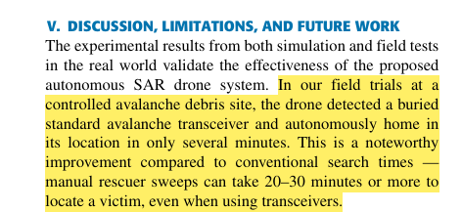

Source 10
Paraphrase, Quotation, or Figure/Table Within Report
Ure et al. (2015) developed an automated battery-swapping system that rapidly replaces depleted batteries with fully charged ones while simultaneously recharging other batteries. During flight testing, the system successfully supported a five-hour autonomous mission with approximately 91% vehicle utilization.
Location in Report
Under Evaluation Section- page 11
Original Source Reference
Ure, N. K., Chowdhary, G., Toksoz, T., How, J. P., Vavrina, M. A., & Vian, J. (2015). An automated battery management system to enable persistent missions with multiple aerial vehicles. IEEE/ASME Transactions on Mechatronics, 20(1), 275–286. https://doi.org/10.1109/TMECH.2013.2294805
Page or Paragraph Number in Original Source
Under Hardware Implementation Flight Test Results- Pages 281,282
Image of Item, With Highlighting
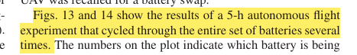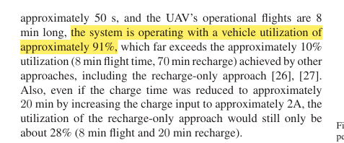
Source 11
Paraphrase, Quotation, or Figure/Table Within Report
According to the Colorado Avalanche Information Center (2024), the state recorded 120 avalanche incidents involving 149 people during the 2023–2024 season.
Location in Report
Page 4 - Introduction
Original Source Reference
Colorado Avalanche Information Center. (2024, October 4). 2023–24 season summary. https://avalanche.state.co.us/blog/2023-24-season-summary
Page or Paragraph Number in Original Source
Paragraph Number 5
Image of Item, With Highlighting

